CHEN 531
Corrosion
Chemical Engineering
Faculty of Engineering and Architecture
American University of Beirut
Friday, February, 1st, 2013
10.00-13.00

This exam paper has 8 questions
Answer all questions
You have 3 hours to complete this exam

GOOD LUCK

Q1. Cavitation damage is a special form of erosion corrosion type. Explain in details its mechanism over protective surface films and conditions to occur. (8 marks)
Q2. What is passivity? Draw a sketch showing all regions for an active-passive metal. Give example for each region. (15 marks)
Q3. Write down five possible cathodic reactions that may occur in case of metal corrosion.
(5 marks)

Q4. Are the following statements true (T) or false (F)?
- In general, "organic" materials are more corrosive than the "inorganic".
- Corrosion in the petroleum industry is due more to sodium chloride and sulfur, than to the oil or gasoline.
- Dry chlorine is practically non-corrosive to ordinary steel, but moist chlorine, or chlorine dissolved in water, is extremely corrosive and attacks most of the common metals and alloys.
- When zinc is placed in dilute HCl, a vigorous reaction occurs while the chloride ion is not involved in the reaction.
- The cathodic reaction that is frequently encountered in metallic corrosion in neutral solutions is O₂ + 2H₂O + 4e⁻ = 4OH⁻
- Concentration polarization usually is the controlling factor during corrosion in media containing a high concentration of active species (i.e., concentrated acids).
- Concentration polarization is only important during reduction reactions.
- Many of the common acids, such as sulfuric, acetic, hydrofluoric and others, are virtually inert when in the pure state, or 100% concentration.
- There is no theoretical way of precisely determining the exchange current density for any given system; it must be determined experimentally.
- The limiting diffusion current density i_{L}, represents the maximum rate of reduction possible for a given system.
- The diffusion layer thickness is influenced by the shape of the particular electrode, the geometry of the system, and by agitation.
- Concentration polarization does not become apparent until the net reduction current density approaches the limiting diffusion current density.
- Although the free-energy change for corrosion of zinc is negative and greater than that for iron, the corrosion rate of zinc is less than that of iron.
- In the uniform attack corrosion, a chemical or electrochemical reaction proceeds uniformly over the entire exposed surface and the metal becomes thinner and eventually fails.
- In the galvanic corrosion, usually the cathode or cathodic metal corrodes very little or not at all in this type of couple.
- Pitting is described as corrosion occurring at contact areas between materials under load subjected to vibrating and slip. It appears as pits or grooves in the metal surrounded by corrosion products.
- If iron is corroding in air-free acid at an electrochemical corrosion rate of 1 μA/cm², it dissolves as ferrous ions (Fe²⁺). Then the corrosion rate is 0.46 mpy.
(25 marks)

Q5. Write all the possible reactions for the following cases. (4 marks)
- Iron is immersed in neutral water
- Iron is immersed in H₂SO₄ solution

Q6. Given that
Cu = Cu²⁺ + 2e⁻ - 0.337 V
Ni = Ni²⁺ + 2e⁻ + 0.25 V
(The indicated redox potentials are at standard conditions)
These two metals were immersed in electrolytic solutions and connected to form a cell.
- Which one of them will be the anode and which one is the cathode?
- What will be the potential between them at standard conditions?
- Which metal undergoes oxidation? Write a balance equation for that.
- Which metal undergoes reduction? Write a balance equation for that
- What is the free energy change (in jouls/mole) for the cell? (15 marks)
Q7. Consider the following polarization data. The measurements were made on a pure Ni electrode in a deaerated acidic solution of NiSO₄ in which both activities of Ni²⁺ and H⁺ are unity. Hydrogen gas at 1 atm pressure was continuously bubbled through the solution.

E (V) | i_{c} (A/cm²) | i_{a} (A/cm²)
-0.123 | 2.0 E -04 | 1.8 E -04
-0.130 | 2.6 E -04 | 1.5 E -04
-0.146 | 4.0 E -04 | 9.6 E -05
-0.157 | 5.0 E -04 | 6.8 E -05
-0.209 | 1.0 E -03 | ---
-0.290 | 2.7 E -03 | ---
-0.374 | 7.1 E -03 | ---

Construct the Evans diagram for this system and determine the following quantities. (20 marks)

  - Tafel slopes for cathode (b_{c}) and for anode (b_{a})
  - E_{corr} and i_{corr}
  - Exchange current densities of anode (i_{o,c}) and for cathode (i_{o,a})
  - Overpotentials for Ni oxidation (η_{A}) and for H⁺ reduction (η_{C}).

Q8. Consider each of the following three Figures. Discuss what does each Figure indicate in terms of corrosion rate. Be brief and specific. (9 marks)
LEGEND: In Figure B, numbers 1 to 7 indicate increasing oxidizer concentration
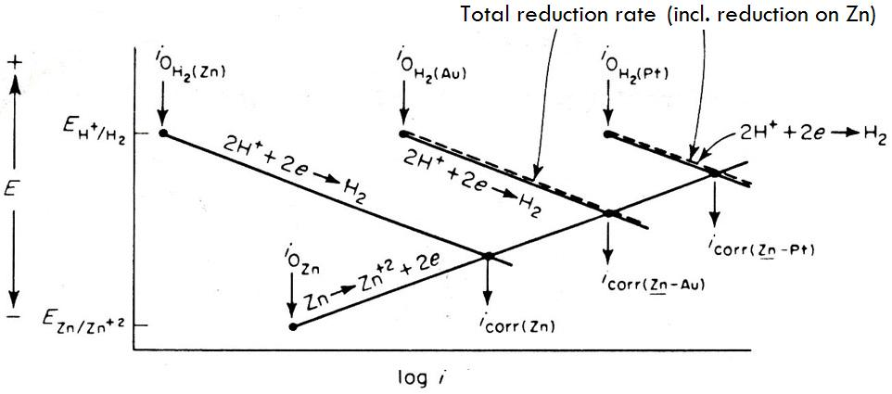
A

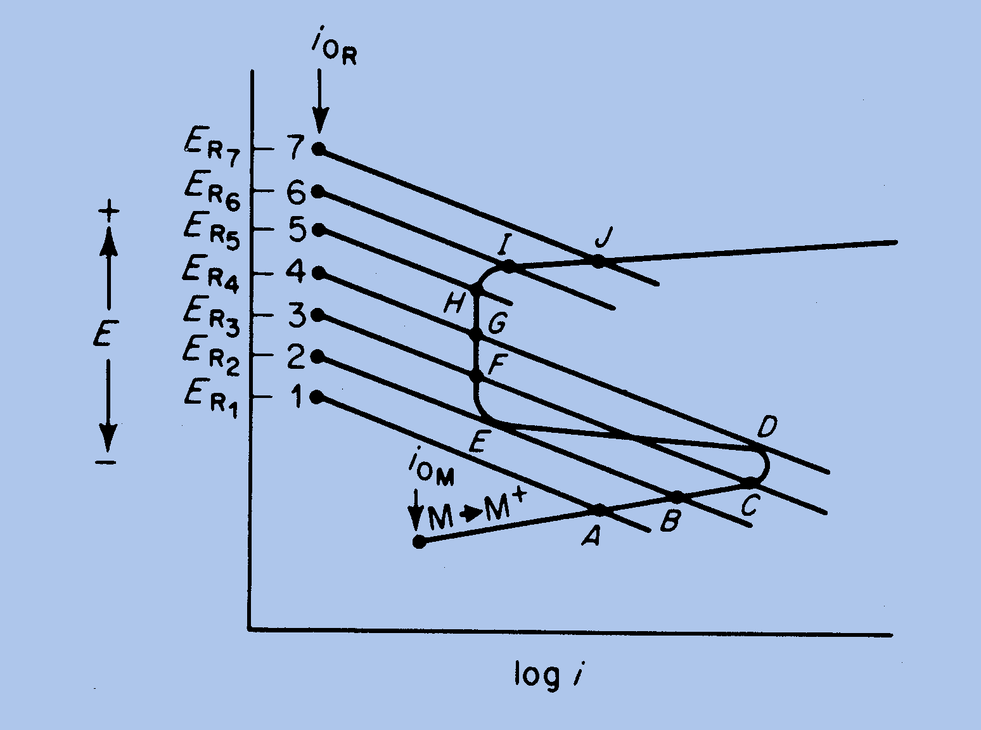
B
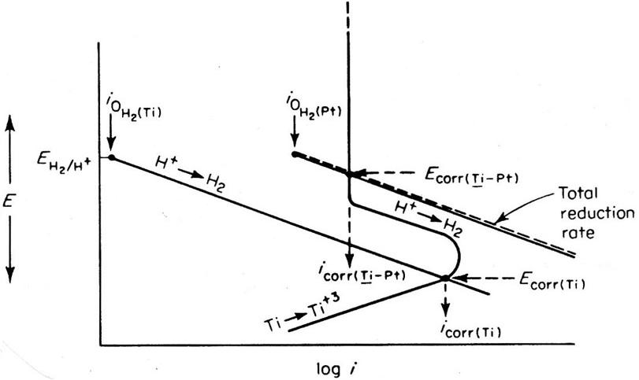
C

EMF Series:
Standard Electrode Potentials
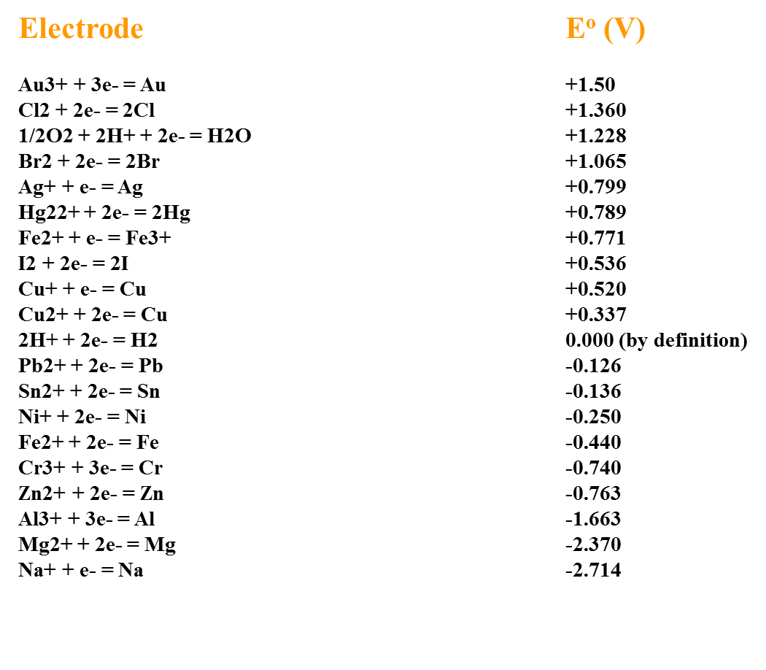
End of Exam

